A Sample of Proceeding Title
(bold Arial 14)

Aname Alastname^{1*}, Bname Blastname^{1,2}, Cname Clastname ³ (Times New Roman 9)
¹ Department of A, Faculty of A, A University, A Road, Acity, Acountry
² Department of B, Faculty of B, B House, B Road, Bcity, Bcountry
³ C Department, Institute of C, C 20, 25105 Ccity, Ccountry
*Corresponding author, e-mail: aaa@aa.ac.th

Abstract
The article submitted must be written in English and contain part I and II. Part I consists of the title (bold Arial 14), authors’ names, authors’ affiliations and email of the corresponding author (Times New Roman 9). The abstract should not exceed 300 words. The abstract should briefly describe the background, objectives, results and conclusion of the research. At the end of the abstract, there are 3 – 5 keywords. Please do not use abbreviations or cite references, figures or tables in the abstract (Times New Roman 9).
Part I

Keywords 3-5 words (Times New Roman 9)

Background (Times New Roman 9)
Part II consists of Background, Materials and Methods, Results, Discussion, Conclusion, Acknowledgement, and References, and must strictly follow the format provided in this template. Please note that the proceeding must be between 4-10 B5 pages, including tables and figures.
Font: please use Times New Roman font for the whole paper except mathematical symbols. Font size: 9 points for the whole paper except the title (Bold Arial, 14 points). Use Bold Times New Roman, 9 points for headings. Paper size: B5; Margin: top 1”; bottom: 1”; left: 0.75”; right: 0.75”, double column format (except the title, author details and abstract). Line spacing: single, please give 1 empty line between sections.
The background section should be brief and written from the standpoint of researchers without specialist knowledge in that area and must clearly state - and, if helpful, illustrate - the background to the research and its aims.
Part II

Materials and Methods
This is the description of the methodology of the research. This section can be divided into sub-sections if necessary. Sub-sections should be written in Italic, Time New Roman, 9 points.

Results and Discussion
The Results and Discussion can be presented either separately or in the combined section. They should be briefly presented with references to include figures and tables. However, they should not be separated into sub-sections for the discussion.

Conclusion
The conclusion should clearly state the main conclusions of the research and give a clear explanation of their importance and relevance. Summary illustrations may be included.

Table 1. Please use ‘text box’ for inserting tables.
(Times New Roman, 8 points)

0.1 | 2.7470e+01 | 2.7483e+01
0.5 | 3.5352e+01 | 3.5360e+01

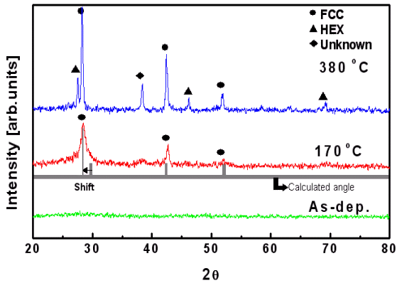
Fig.1 Caption (Times New Roman, 8 points, justified). Please use ‘text box’ for inserting figures. Figures may also be inserted into the column.

Acknowledgements
These should be kept to a minimum.
(Times New Roman, 9 points)

References
- You CH, Lee KY, Chey RY, Menguy R. Eletrogastrographic study of patients with unex plained nausea, bloating and vomiting. Gastroenterology 1980; 79: 311-4.
- Chomczynski P, Sacchi N. Single-step method of RNA isolation by acid guanidinium thiocyanate-phenol-chloroform extraction. Anal Biochem 1987, 162: 156-159.
- Sambrook J, Fitsch EF, Maniatis T. Molecular Cloning: A Laboratory Manual. Cold Spring Harbor: Cold Spring Harbor Press, 1989.
- Wessely S, Wood F. Peer review of grant applications: a systematic review. In: Godlee F, Jefferson T, editors. Peer Rreview in Health Sciences. London: BMJ Books, 1999: 14-31.
- Advisory Committee on Genetic Modification. London: Annual Report, 1999.
(Times New Roman, 9 points)

